**TASK 1**

**YEAR 11 ATAR PSYCHOLOGY**

**SEMESTER 1 2024 - UNIT 1**

**Science Inquiry & Biological Psychology**

**Name: ___________________**

**Syllabus points**

* Science Inquiry: Ethical guidelines, formulating research, communicating
* Biological psychology

**Conditions**

* Reading time: 5 minutes
* Working time: 50 minutes

**Task Weighting**

* 10%

**Structure of this paper**

|  |  |  |  |  |  |
| --- | --- | --- | --- | --- | --- |
| Section | Number of questions available | Number of questions to be attempted | Suggested working time  (minutes) | Marks | Score |
| Section One:  Science Inquiry | 1 | 1 | 15 | 12 |  |
| Section Two:  Short Answer | 1 | 1 | 35 | 38 |  |
|  |  |  | **Total** | 50 |  |

**Section One: Science Inquiry 20% (12 Marks)**

This section has **one** question. Write your answers in the spaces provided.

Suggested working time: 15 minutes.

Question one (12 marks)

The ability to recognise the intensity of emotions is an important social skill. Researchers from Jena University were interested in finding out whether neural activity increased more quickly when year 7 students are exposed to emotional or neutral facial expressions. Participants identified their responses to a series of photographs of people that showed neutral and emotional facial expressions. They used a mouse with their right hand to press a button to identify either emotional or neutral expressions. The researchers measured the speed of the responses.

1. Write a directional hypothesis for this research study. (4 marks)

|  |
| --- |
|  |
|  |
|  |
|  |
|  |

Forty five participants were recruited into the sample based on recommendations from other participants in the sample group.

1. Define the term ‘population’ in the context of psychological research. (1 mark)

|  |
| --- |
|  |
|  |

The study was approved by the Ethics Committee of the University of Jena and all participants gave informed consent prior to their participation.

1. Describe the role of ethics in psychological research. (1 marks)

|  |
| --- |
|  |
|  |
|  |
|  |

1. Define the concept of informed consent and explain how a researcher should ensure informed consent is attained. (4 marks)

|  |
| --- |
|  |
|  |
|  |
|  |
|  |

The University of Jena wanted to publish the results of this research in a psychological journal.

1. Outline the ethical concept that applies to publishing the results of this research (2 marks)

|  |
| --- |
|  |
|  |
|  |
|  |
|  |

**Section Two: Short Answer 80% (30 Marks)**

This section has **four** questions. Write your answers in the spaces provided.

Suggested working time: 30 minutes.

**Question two (14 marks)**

Zendi is walking home from university at 10 pm at night. He could hear the rustle of the tree branches in the wind and hears footsteps behind him.

1. 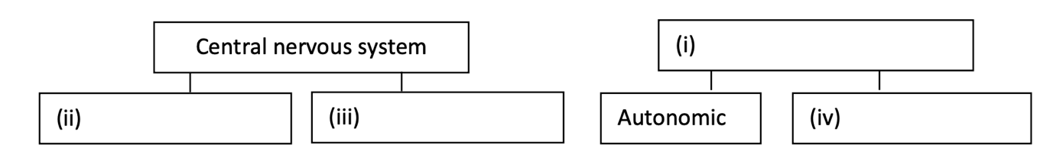Complete the following diagram to identify the structures of the human nervous system (4 marks)
2. Identify and describe the function of the neuron activated when Zendi hears the rustle of the tree branches. (2 marks)

|  |
| --- |
|  |
|  |
|  |

1. Complete the table below to explain the role of each branch of Zendi’s autonomic nervous system responding to sensory stimuli as he walks home from university. (4 marks)

|  |  |  |
| --- | --- | --- |
| **Branch** | **Role** | **Physiological response** |
| Sympathetic |  |  |
|  | Calms the body down and returns it to normal level of arousal (after threat has passed) to conserve energy |  |

**Question three (8 marks)**

1. Shade the hindbrain in the following diagram. (1 mark)



1. State **two** functions of the cerebellum. (2 marks)

|  |
| --- |
|  |
|  |
|  |

1. Describe the location and function of the following parts of the brain. (5 marks)

|  |  |  |
| --- | --- | --- |
| **Part of the brain** | **Location** | **Function** |
| Reticular formation | Midbrain |  |
| Primary motor cortex |  | Generates neural impulses that control movement |
| Occipital lobe |  |  |

**Question four (11 marks)**

Dr Quinn has a patient who has suffered a stroke. The patient is also having difficulty recognising faces, and when asked to, they draw the below picture.

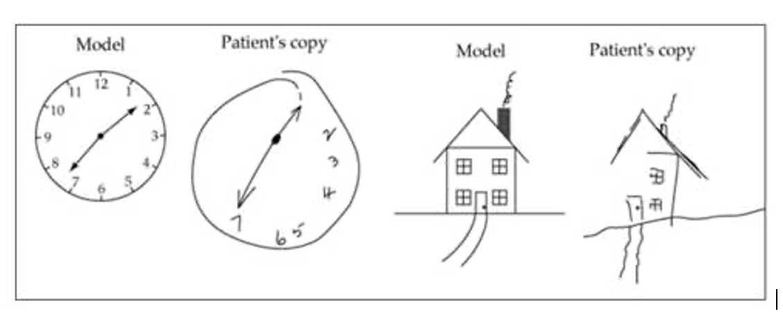

1. Identify which hemisphere of the brain has been damaged. (1 mark)

|  |
| --- |
|  |

1. With reference to the symptoms, explain which lobe of the cerebral cortex has been damaged.

(3 marks)

|  |
| --- |
|  |
|  |
|  |
|  |

1. Explain how electroencephalography (EEG) is used to investigate the patient’s brain damage.

(3 marks)

|  |
| --- |
|  |
|  |
|  |
|  |

1. Outline one strength and one limitation of electroencephalography in investigating brain damage. (2 marks)

|  |
| --- |
|  |
|  |
|  |

1. Identify a different brain imaging technique Dr Quinn could use for this patient and explain why it is more appropriate than electroencephalography. (2 marks)

|  |
| --- |
|  |
|  |
|  |
|  |

**Question five (5 marks)**

Students of psychology are often familiar with the name Phineas Gage.

1. Identify the lobe of the brain damaged in Phineas Gage’s accident. (1 mark)

|  |
| --- |
|  |

1. Recall the events that took place which led to his injury. (3 marks)

|  |
| --- |
|  |
|  |
|  |
|  |

1. Explain how Phineas Gage’s injury has contributed to psychological research of the brain.

(1 mark)

|  |
| --- |
|  |
|  |
|  |